4-H Livestock Market Project

MARYLAND 4-H ANIMAL SCIENCE -
LIVESTOCK MARKET PROJECT RECORD

Name |  | 4-H Age
Primary Club Name
Years in 4-H |  | Years in this Project:
I have completed this record and believe all information to be complete and accurate. (Print and sign/date.)

____________________________ ________________ ___________________________ _______________
Member’s Signature Date Parent’s Signature Date

Please indicate your Animal Science Project Area
 | Beef/Dairy Steer |  | Market Goat |  | Market Sheep |  | Market Swine

What goals did you set for your project this year and how did you achieve them?

What were two things you learned from completing this project this year?

What is one thing you would like to improve or do differently with your project next year?
MARYLAND 4-H LIVESTOCK MARKET PROJECT RECORD

Life Skills
Describe the Life Skills you used and what you learned in relation to your project.

Example Table
I used one or more of these Life Skills from the Targeting Life Skills Wheel | What I learned as a result of using this skill.
HEAD  Example: Decision Making | I learned that I needed to be sure to budget my money when purchasing my rabbit projects so I would have enough to cover all of my expenses.
HEART  Example: Sharing | I learned how to give younger 4-H members pointers on how to fit and show their animals properly.
HAND  Example: Healthy Life Choices | I learned that animals don’t grow well unless they receive the proper food.
HEALTH  Example: Managing Feelings | I learned to control my feelings when I became frustrated that my pig would not cooperate to get loaded on the trailer.

I used one or more of these Life Skills from the Targeting Life Skills Wheel | What I learned as a result of using this skill.
HEAD
HEART
HAND
HEALTH
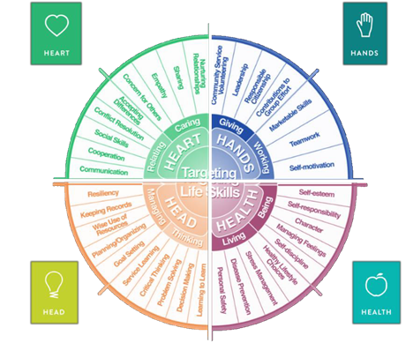

MARYLAND 4-H
LIVESTOCK MARKET PROJECT RECORD

Project Activities
Include: Field Trips. Skillathon, Judging, Workshops, Quality Assurance, Class Participation, etc.
All project activities listed should be about this project area only.
Date | Name of Activity/Event | Location  (school, club, county, state, national, etc.)

Project Communications
Include: Speeches, Demonstrations, Visual Presentations, etc.
All project communications listed should be about this project area only.
Date | Type of Communication | Title | Location  (school, club, county, state, national, etc.)

Project Exhibits
Include: Fair, Shows, Community Events, Contests, etc. All project exhibits listed should be for this project area only.
Date | Exhibit/Class | Event/Activity | Placing

Table 1: Information on Project Animals
Project Animal Description |  |  | Beginning of Project |  |  | End of Project |  |  |  | Final Production
Breed | Sex | ID 4-H Tag # | Weigh-In Date | Weight | Purchase Cost of Market Value | Weigh In Date | Weight | Selling Price or Market Value | Death, Loss, or Sold Date | Days on Feed | Lbs Gained | Lbs per Day
TOTALS:

Lbs Gained Per Day

To calculate lbs. gained, take the lbs. gained and divide by the number of days on feed.

Table 2: Feed Expenses
Date Purchased | Type of feed (grain, mix, hay, supplement, pasture, silage) | $/lb (total cost divided by lbs) | Pounds (lbs) | Total Cost
Total pounds and total feed costs

Feed Efficiency

To calculate feed efficiency take the total pounds gained by all of your market animals and divide that by the total pounds of feed you have fed them.
Feed Efficiency =

Table 3: All Other Expenses
Bedding, Insurance, Entry Fees, Equipment, Sale Commission, Supplies, etc.
Date | Description of Item or Expense | Cost
Total of All Other Expenses
Table 4: Health and Veterinary Expenses
List practices & materials used to treat or protect your animals from parasites, illnesses, & diseases. Include veterinary examinations, health papers, treatments for illnesses or injuries, foot care, vaccinations, medications & dewormers. etc.
Date (s) Treated | 4-H Tag # or Animal ID | Reason for Treatment or Veterinary Visit | Treatment Given | Withdrawal Period |  | Cost
 |  |  |  | Days | Date completed
Total Health and Veterinary Costs

Table 5: Sale Income
Income from animals sold through 4-H Livestock Sale(s), Privately Sold, Sold at Livestock Auction, etc.
Date Sold | Description of Income (Include 4-H Tag #) | Final Weight | Gross Sale (Amount of Check) | $/lb (net sale/final weight
Total weight and value of animals sold |  |  |  | N/A

Table 6: All Other Income
Include all other income from project animal(s) including premiums, products (wool, etc.), etc.
Date | Description of Income | Income $
Total All Other Income

Financial Summary: Please make sure to use the above totals.
Determine how much money you made or lost on your project animals. You can determine your profit/loss by:
- Income | - Sale Animal Income (Table 5) | $
 | - All Other Income (Table 6) | $
 | Total Income (A) | $
- Expenses | - Project Animal Costs (Table 1) | $
 | - Feed Expenses (Table 2) | $
 | - All Other Expenses (Table 3) | $
 | - Health and Veterinary Expenses (Table 4) | $
 | Total Expenses (B) | $
- Total | Subtract B from A to get total | $  (Profit or loss)

