Maryland 4-H Animal Science – Poultry Project Record
Name |  |  | 4-H Age
Primary Club Name
Years in 4-H |  |  | Years in this Project
I have completed this record and believe all information to be complete and accurate.

Member’s Signature Date Parent’s Signature Date

______________________ ________ _______________________ ________
Leader’s Signature Date Educator’s Signature Date
Please select your 4-H Project below: (check all that apply)
Chickens | - Gamebirds (quail, pigeons, guinea fowl,
- Broiler/Roaster (Meat Production/Market) | partridges & pheasants)
- Egg Production | - Turkeys
☐ Fancy Birds | - Waterfowl (ducks & geese)
What goals did you set for your project this year and did you achieve them?
1.

2.

3.

What were four things you learned from completing this project this year?
1.

2.

3.

4.

What is one thing you would like to improve or do differently with your project next year?
Life Skills
Describe the Life Skills you used and what you learned in relation to your project.
Example Table
I used one or more of these Life Skills from the Targeting Life Skills Wheel | What I learned as a result of using this skill.
HEAD  Example: Decision Making | I learned that I needed to be sure to budget my money when purchasing my rabbit projects so I would have enough to cover all of my expenses.
HEART  Example: Sharing | I learned how to give younger 4-H members pointers on how to fit and show their animals properly.
HAND  Example: Community Service Volunteering | I took my lambs to the elementary schools “Ag Day” and I was able to teach and expose 100 students about my lamb project.
HEALTH  Example: Managing Feelings | I learned to control my feelings when I became frustrated that my pig would not cooperate to get loaded on the trailer

I used one or more of these Life Skills from the Targeting Life Skills Wheel | What I learned as a result of using this skill.
HEAD | 1.  2.
HEART | 1.  2.
HAND | 1.  2.
HEALTH | 1.  2.

The diagram below shows many of the Life Skills learned in 4-H:
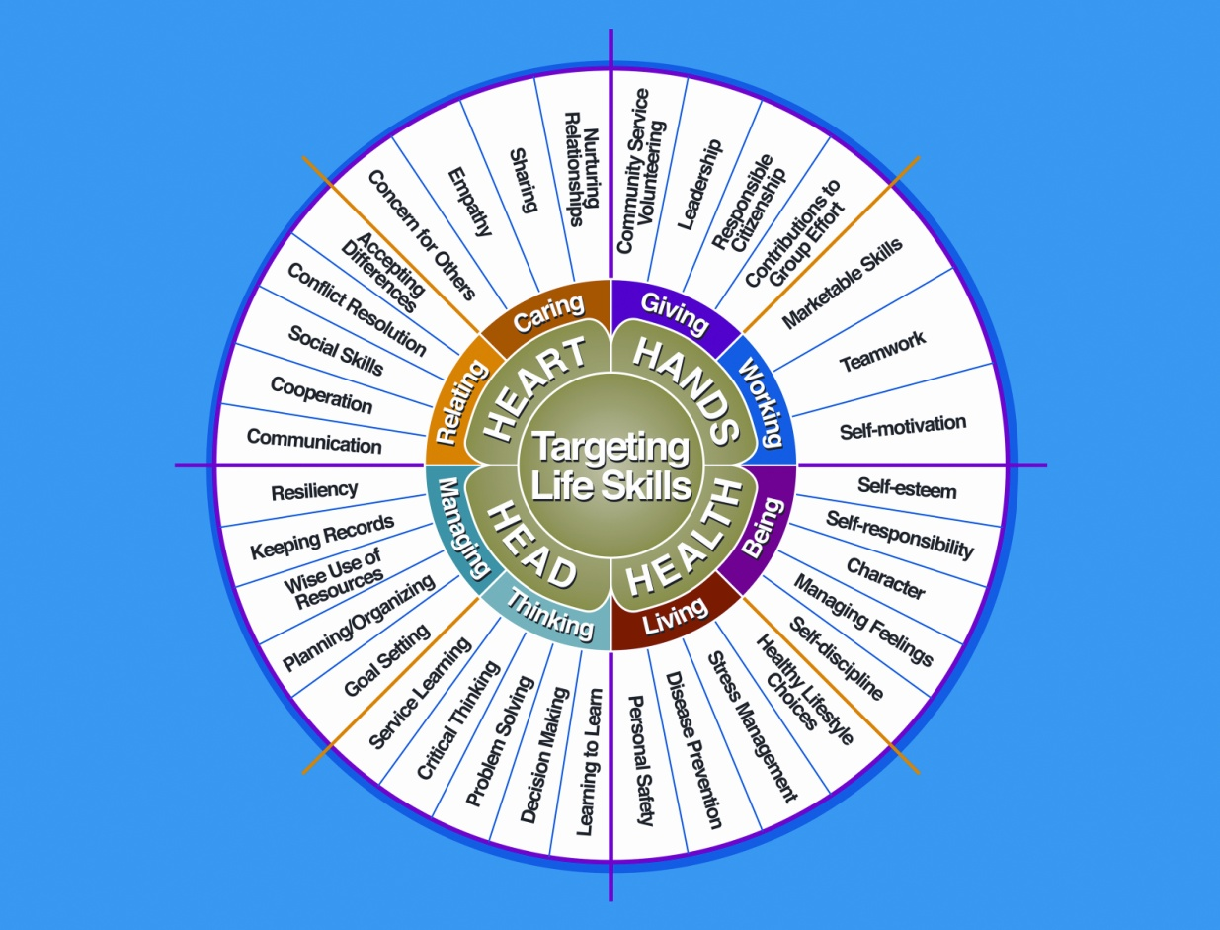

Courtesy of Iowa State University-Used with Permission 11/2012
Project Activities
Include: Field Trips, Skillathon, Judging, Workshops, Quality Assurance, Class Participation, etc.
All project activities listed should be about this project area only.
Date | Name of Activity/Event | Location  (School, Club, County, Regional, State, National etc.)

Project Communications
All project communications listed should be about this project area only.
Date | Type of Communication  (Speech, Demonstration, Visual Presentation, etc.) | Title | Location  (School, Club, County, Regional, State, National etc.)

Project Exhibits
Include: Fairs, Shows, Community Events, etc.
All project exhibits listed should be for projects in this area only.
Date | Exhibit | Location/Event | Placing  (if applicable)

Table 1: Poultry Inventory
Fill in the following information (where applicable) about animals that are part of your project
Animal/  Band Number or  Lot  Number | Breed |  | Color/  Variety |  | Sex | Date of Hatch | Date of Purchase  (if applicable) |  | Value at Beginning or Cost of Purchased |  | Current Status  (Own, Sold, or Died) |  | Value at End
Total |  |  |  |  |  |  |  |  |  |  | Total at Project End
Table 2: Breeding Information
(Only include birds that are of breeding age)
Animal/Band Number |  | Date Bred |  | Male Used for Breeding |  |  |  | Date Chicks Hatched |  | Number Hatched |  | Number Raised

Table 3: Incubation and Hatching Information

Date Eggs Set | Number Eggs Set | Date Chicks Hatched | Number Hatched | Number Raised | Incubation Method Used

Table 4: Feeding Information and Expenses

Date |  | Type of Feed |  | Quantity of Feed/Day |  |  | Cost
Total Feed Cost
Table 5: Health and Veterinary Record and Expenses
(Vaccines, Blood Testing, Routine Checks, etc.)
Date(s) Treated | Reason For Treatment/Visit |  | Treatment |  | Number of Animals Treated | Withdrawal Period |  | Cost
 |  |  |  |  |  | Days | Date Completed
Total Health and Veterinary Cost

Table 6: All Other Expenses
(Includes: Equipment, Supplies, Processing etc.)
Date | Describe Item | Cost
Total Other Expense Costs |  | $

Table 7: Egg Production

Week | Number of Eggs Produced |  | Variety of Eggs | Value of Eggs Produced |  | Week | Number of Eggs Produced | Variety of Eggs |  | Value of Eggs Produced
Total Value of Egg Sales |  |  |  |  |  | Total Value of Egg Sales
Table 8: Poultry and Meat Sales

Date |  | Number Sold (Birds or Pounds) |  |  | Type Sold (Live Poultry, Meat) |  |  |  | Value
Total Value of Poultry and Meat Sales

Financial Summary: Please make sure to use the above totals.

Determine how much money you made or lost on your project animals. You can determine your profit (or loss) by:

- Add Income
- Value of Animals on Hand at the End of the Project (Table 1) $ ________
- Money Received from Sale of Eggs (Table 7) $ ________
- Money Received from Sale of Live Poultry or Meat (Table 8) $ ________

Total Income (A) $ ________
- Add Expenses
- Total Value of Animals on Hand and Purchased (Table 1) $ ________
- Feed Expenses (Table 4) $ ________
- Health and Veterinary Expenses (Table 5) $ ________
- All Other Expenses (Table 6) $ ________

Total Expenses (B) $ ________

Subtract B from A to get profit or loss Total $ ________ (profit or loss)

University of Maryland Extension programs are open to all persons and will not discriminate against anyone because of race, age, sex, color, sexual orientation, physical or mental disability, religion, ancestry, or national origin, marital status, genetic information, or political affiliation, or gender identity and expression.

3/2013

