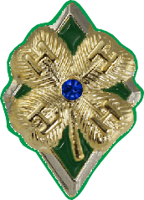Address: Town/State/Zip: 4-H County or Baltimore City: Club(s):
Maryland 4-H Diamond Clover Award Program
Level 4 (Sapphire)
Name: Phone:

4-H Age:
Birth Date:
Years in 4-H: (including this year)

Directions: At the beginning of the year, complete section 1 and 2 with the appropriate signatures.
At the end of the year, complete section 3 with the appropriate signatures. A 4-H Club/Group Leader must approve the Diamond Clover Plan prior to when you start the activities.

Section 1: Diamond Clover Level 4 Goals Checklist
Choose at least seven goals for this year: You are encouraged to choose goals from all four H categories. You may also write in a maximum of two self-determined goals. 4-H life skills are shown in italics.

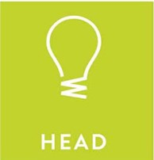
Complete at least one 4-H project from a new project area and find out the project
record and the 4-H summary record. (keeping records, learning to learn)
With permission of a parent/guardian, contact a representative of a local or state civic
engagement, non-profit, community service, or government agency or committee. Interview them and out how the organization determines community needs. (critical thinking, decision making, service learning)
Plan and maintain a detailed budget for a project/workshop you are working on.

(planning/organizing, keeping records)
With the permission of your parent/guardian, contact an adult mentor or teen leader through a letter, e-mail, or phone call to ask for assistance with a project or activity. (nurturing relationships)
Participate in a communication event. (public speaking, visual presentation/workshop, etc.) (communication)
Self-determined. Apply a life skill from 4-H to another area of your life.
Goal: Life Skill:

University programs, activities, and facilities are available to all without regard to race, color, sex, gender identity or expression, sexual orientation, marital status, age, national origin, political affiliation, physical or mental disability, religion, protected veteran status, genetic information, personal appearance, or any other legally protected class.
1

Assist with the planning and leadership of a club or community service learning project.

(concern for others)
Assist with the planning and leadership of a club or community fundraiser. (concern for others) Assist a younger youth with a project, workshop, or demonstration. (nurturing relationships) With the permission of a parent/guardian, write a letter about a community need to a community partner. (communication, nurturing relationships, cooperation)
Participate in a communication event (public speaking, visual presentation, workshop, etc.)

(communication)
Self-determined. Apply a life skill from 4-H to another area of your life.
Goal: Life Skill:

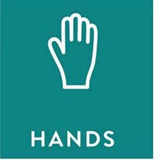
Assist with the planning and leadership of a club or community activity, workshop, or presentation. (leadership)
Participate in a multi-county, regional, or state 4-H event. (self motivation) Participate in a 4-H day or residential camp, conference, or overnight experience. (self-motivation)
Make a presentation, video, or flyer to teach people about or promote a 4-H club or
event. (marketable skills)
Teach a community group about a topic of importance in your area; explain why it is important, how it affects the community and how others can be involved. (responsible citizenship)
Serve as an officer or committee or program chair/leader for a club or group such as county/city or state committee, national group, school group, community committee, etc. (leadership)
Self-determined. Apply a life skill from 4-H to another area of your life
Goal: Life Skill:

Attend at least 70% of meetings or trainings. (self-responsibility)
Lead a healthy living activity (nutrition, fitness, etc.) for a club or group meeting.

(healthy lifestyle choices)
Serve as a mentor for a new 4-H member or family to help them feel comfortable with
their first year in 4-H. (self-esteem)
Work with your club or group leader to ensure that a meeting or other activity will be held in a safe manner and in a safe location. (personal safety)
Self-determined. Apply a life skill from 4-H to another area of your life.
Goal: Life Skill:

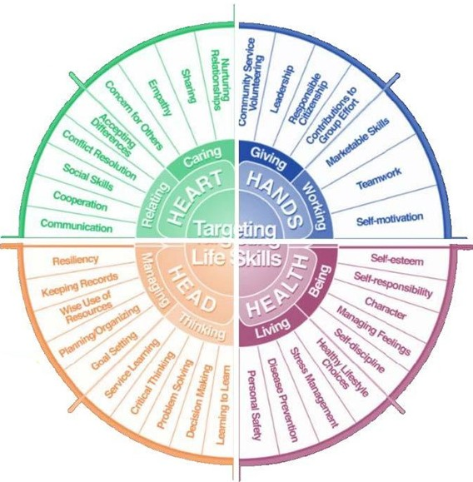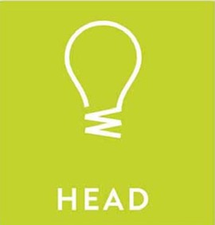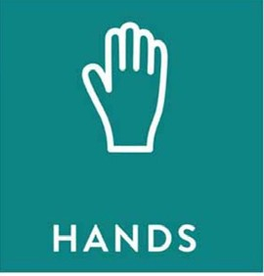

Hendricks Life Skills Wheel

Section 2: Youth and Adult Signatures
I have chosen a minimum of seven goals for my Level 4 project. I will request support as needed to ensure the achievement of my goals.

4-H Member Signature: Date:

I have reviewed this plan and find it complete, accurate, and acceptable to meet the requirements of the Maryland 4-H Diamond Clover Level Four project. I am willing to support the 4-H member to ensure the achievement of this project.

Parent/Guardian Signature: Date:

Club/Group Leader Signature: Date:

Section 3: Youth Reflection

List the completed goals and the dates they were completed. Explain how you used the related life skills to accomplish the goals. Note: Goals do not need to be reached in a particular order.

First Goal: Date:

Explain how you used a life skill to reach this goal.

Second Goal: Date:

Explain how you used a life skill to reach this goal.

Third Goal: Date:

Explain how you used a life skill to reach this goal.

Fourth Goal: Date:

Explain how you used a life skill to reach this goal.

Fifth Goal: Date:

Explain how you used a life skill to reach this goal.

Sixth Goal: Date:

Explain how you used a life skill to reach this goal.

Seventh Goal:
Date:

Explain how you used a life skill to reach this goal.

I have reviewed this report and find it to be complete, accurate, and meeting the requirements of
this level as part of the Maryland 4-H Diamond Clover Award Program.

4-H Member Signature: Date:

4-H Parent/Guardian Signature: Date:

4-H Club/Group Leader Signature: Date:

University programs, activities, and facilities are available to all without regard to race, color, sex, gender identity or expression, sexual orientation, marital
status, age, national origin, political affiliation, physical or mental disability, religion, protected veteran status, genetic information, personal appearance, or
any other legally protected class. 5

