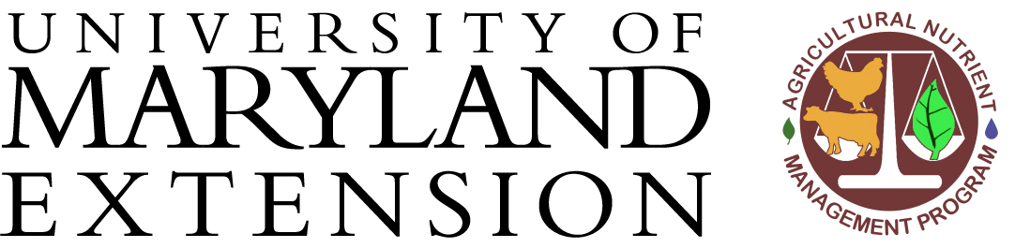

Nutrient Recommendations for Bearing Perennial Fruit Crops

Block:
Crop:

Nutrient | Concentration in Plant Tissue | Relative Level in Plant Tissue | Relative Level in Soil | Recommendation
Soil pH
Nitrogen
(N) %

Phosphorus
(P) %
Potassium
(K) %
Calcium
(Ca) %
Magnesium (Mg) %
Boron
(B) ppm
Zinc
(Zn) ppm
Manganese
(Mn) ppm
Iron
(Fe) ppm
Copper
(Cu) ppm
Agricultural Nutrient Management Program
07/17

